**Setting up git in VS Code**

I have installed git, pull requests and Issues extension and then cloned my project repository to the VSCode.

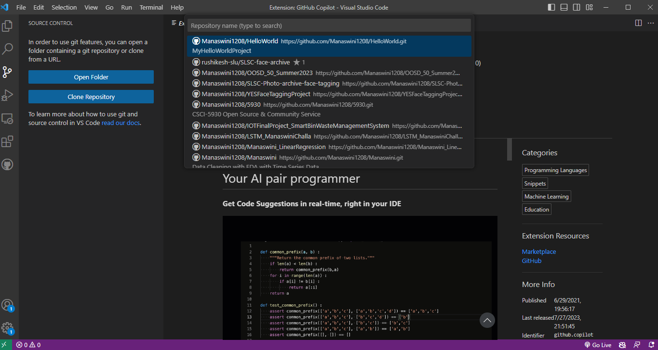

**Cloning our project Repository**

In this step, I have cloned the project repository and did the angular setup in my local.

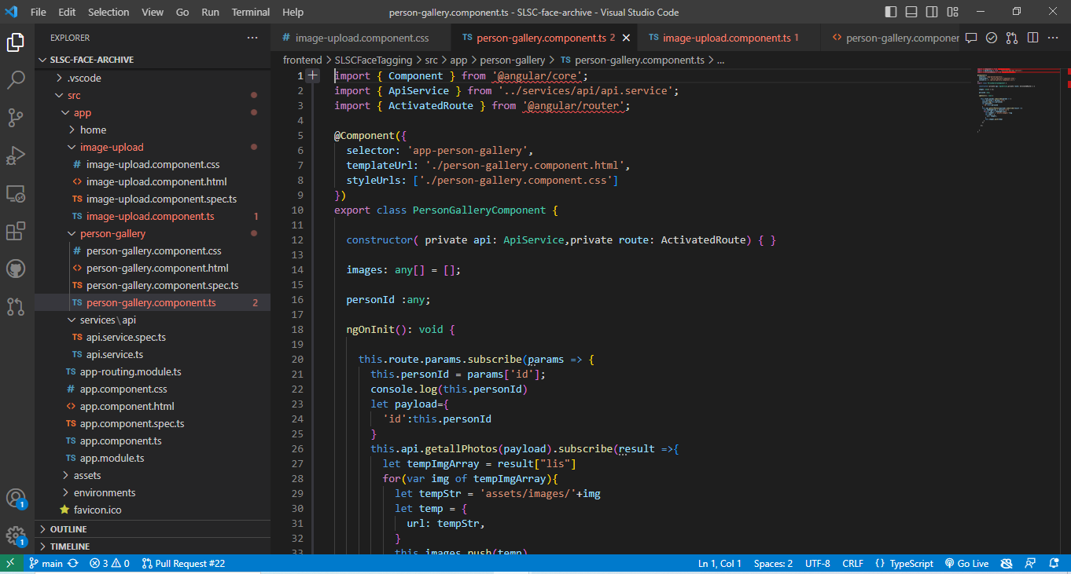

Checking the pull requests.

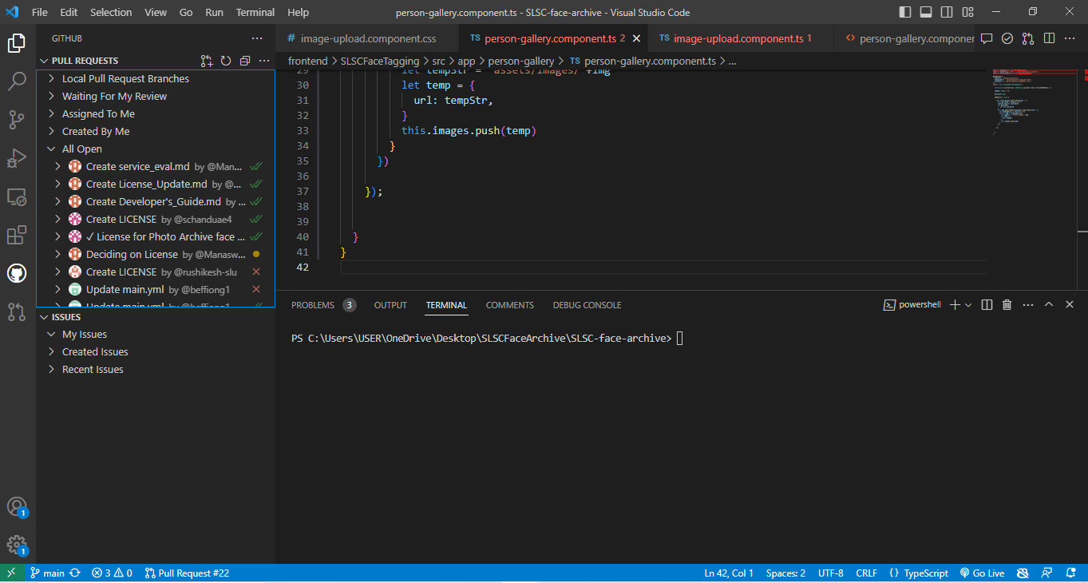

**Issues**

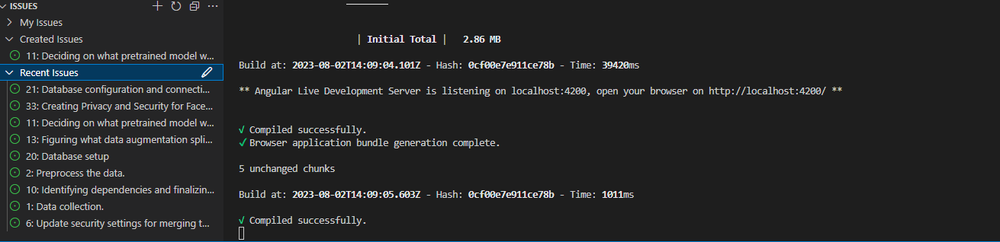

**Application**

